Lab 2.1:

AWS Services - Installation and Tasks

In the Lab 2.1, you will learn about the cloud technologies used for deploying an application in the AWS Cloud. In the first part, you will learn how to create an virtual machine on AWS, and how to deploy an application on that virtual machine. You will also gain hands-on experience with AWS security groups, and troubleshooting network issues. In the second part, you will learn how to deploy an application using the AWS Container Service.

Overview:

[Student Group Information 1](#_Toc1)

[Prerequisites 2](#_Toc2)

[Part 1- AWS EC2 2](#_Toc3)

[Task 1.1 2](#_Toc4)

[Task 1.2 7](#_Toc5" \o "#_Toc5)

[Task 1.3 10](#_Toc6" \o "#_Toc6)

[Task 1.4 14](#_Toc7" \o "#_Toc7)

[Task 1.5 15](#_Toc8" \o "#_Toc8)

[Part 2 - AWS Elastic Containers 15](#_Toc9" \o "#_Toc9)

[Task 2.1 15](#_Toc10" \o "#_Toc10)

[Task 2.2 16](#_Toc11" \o "#_Toc11)

[Task 2.3 16](#_Toc12" \o "#_Toc12)

[Task 2.4 16](#_Toc13" \o "#_Toc13)

[Task 2.5 16](#_Toc14" \o "#_Toc14)

[Task 2.6 17](#_Toc15" \o "#_Toc15)

[Part 3 – Reflective Tasks 17](#_Toc16" \o "#_Toc16)

[Task 3.1 17](#_Toc17" \o "#_Toc17)

[Task 3.2 19](#_Toc18" \o "#_Toc18)

[Task 3.3 21](#_Toc19" \o "#_Toc19)

# Student Group Information

Enter your student group information in the following table and provide your group number.   
(This number will be important for later labs as well, please remember it!)

**GroupNumber (e.g. Group01):** Group\_10

|  |  |
| --- | --- |
| **Member Name** | **Matriculation Number** |
| **Chowdhury Abida Anum Era** | **7219089** |
| **Nimisha Vilayatarani** | **7219293** |
| **Eraj Rizvi** | **7219193** |

# Prerequisites

* An AWS account (AWS offers a Free Tier plan):. [https://aws.amazon.com/free/](https://aws.amazon.com/free/" \o "https://aws.amazon.com/free/)
* Basic knowledge of the command line interface.
* Install AWS CLI: [https://docs.aws.amazon.com/cli/latest/userguide/getting-started-install.html](https://docs.aws.amazon.com/cli/latest/userguide/getting-started-install.html" \o "https://docs.aws.amazon.com/cli/latest/userguide/getting-started-install.html)
* Understanding the Docker installation process and knowledge to build a docker image.

# Part 1- AWS EC2

Introduction: Consider that you are the CTO of the start-up company that runs the online shop. As you get quite a lot of traffic on your shop you have decided to deploy the shop front-end application in the cloud. After doing research, you want to deploy the online shop application using the cloud services of AWS.

**Important: Always remember to stop your AWS EC2 instance if you are not using it!**

## Task 1.1

You need to create an AWS EC2 Instance, remember to use the t2.micro plan which is for the free tier. Write down the steps to create it and the resources provided for this instance. (Hint.: select RAM, CPU etc.)?

1st step:-

Search for ec2 instance after log in through console.

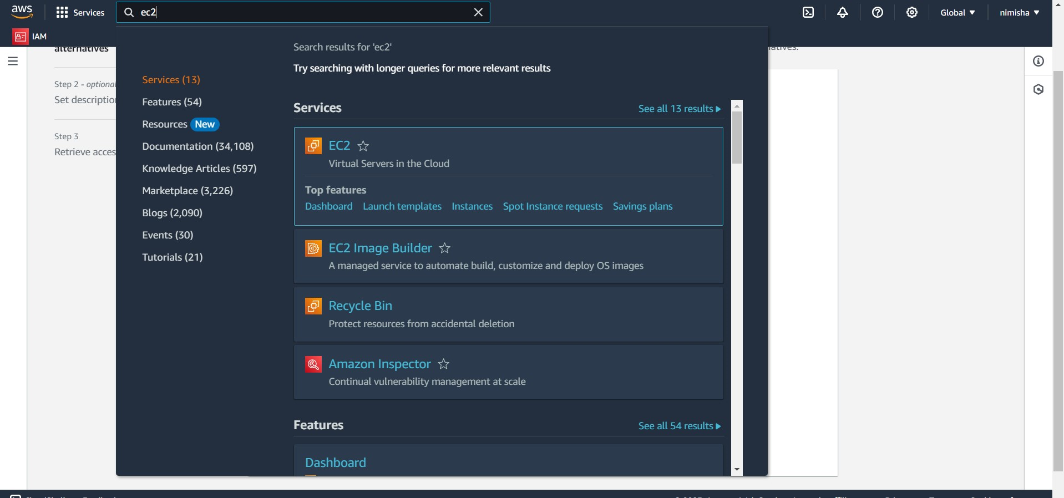

2nd step:- click on launch instance

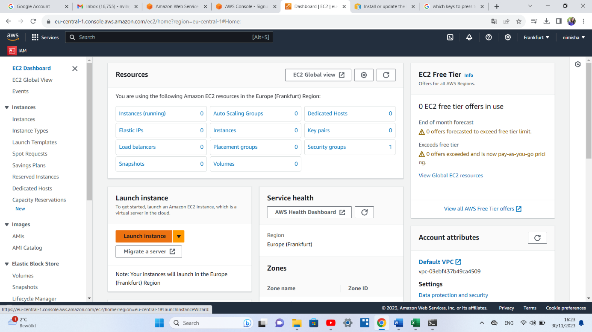

3rd step:-Then give name to our ec2 instance

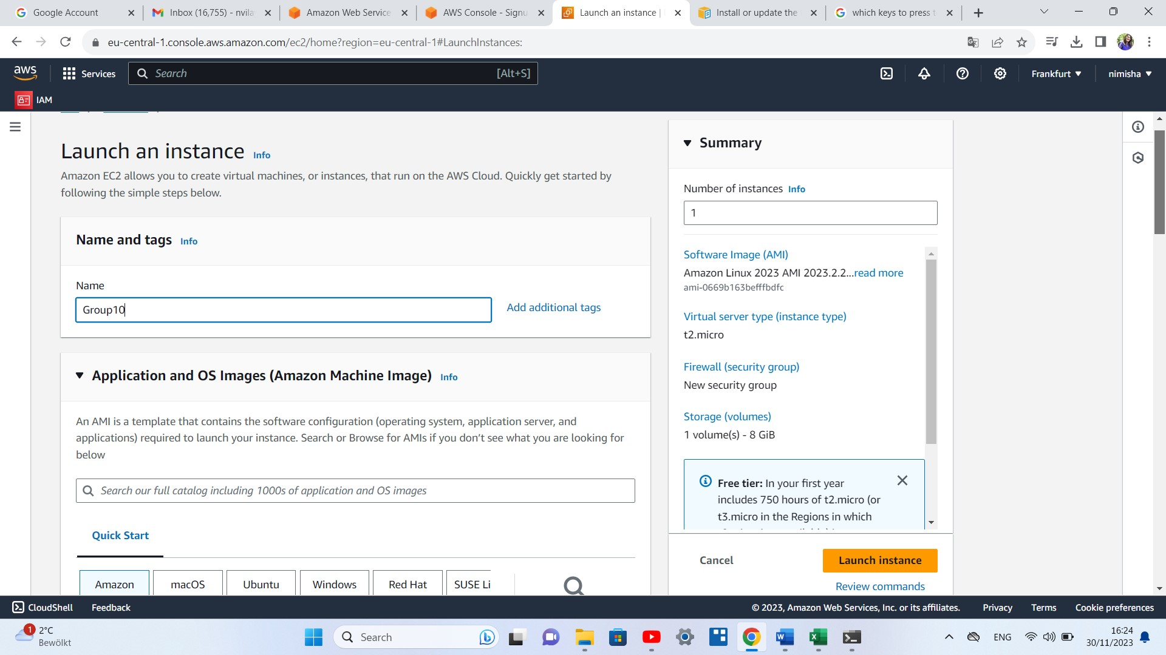

4th step:-select an image (in my case I had selected ubuntu),t2microns (I cpu,1gib ram)

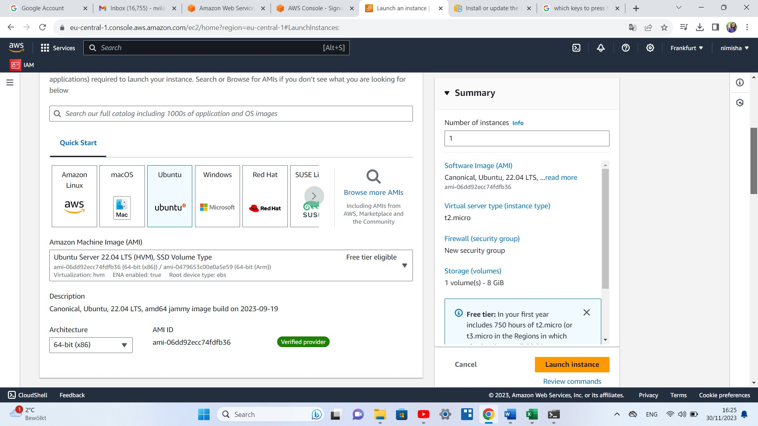

5th step:-Generate the key (.pem ) file which contain private key and password in downloads

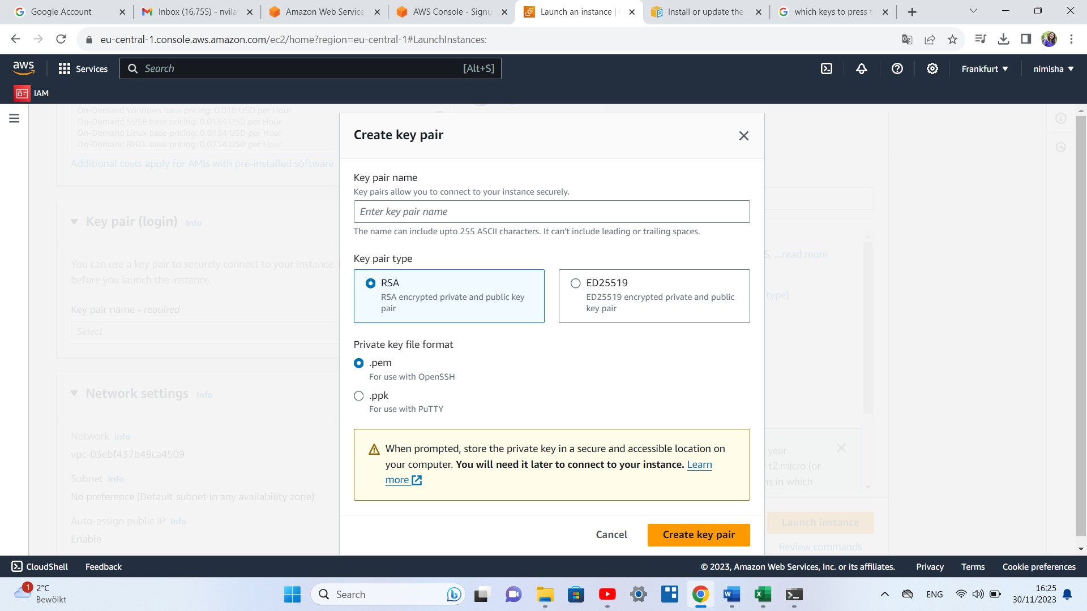

6th steps storage(limited to free tier only)

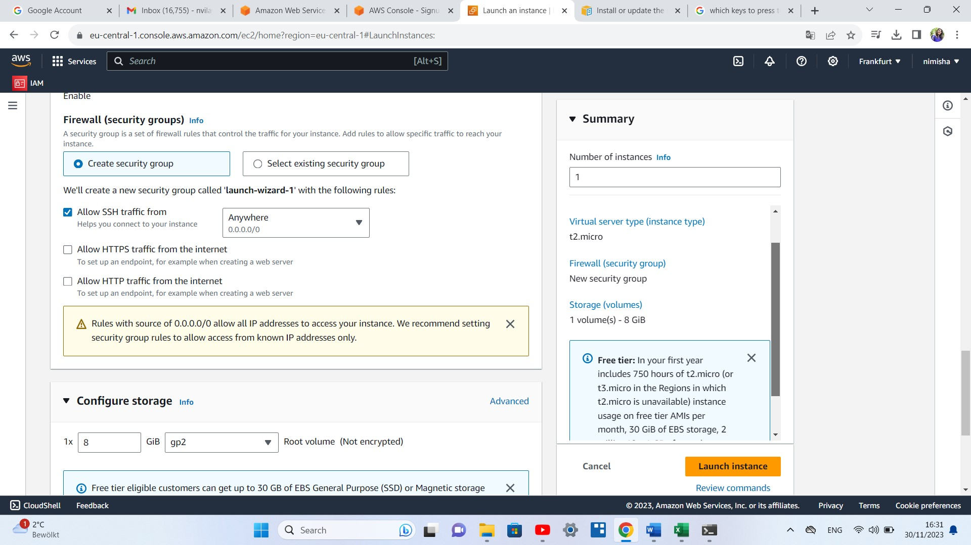

7th step:- finally launch instance .

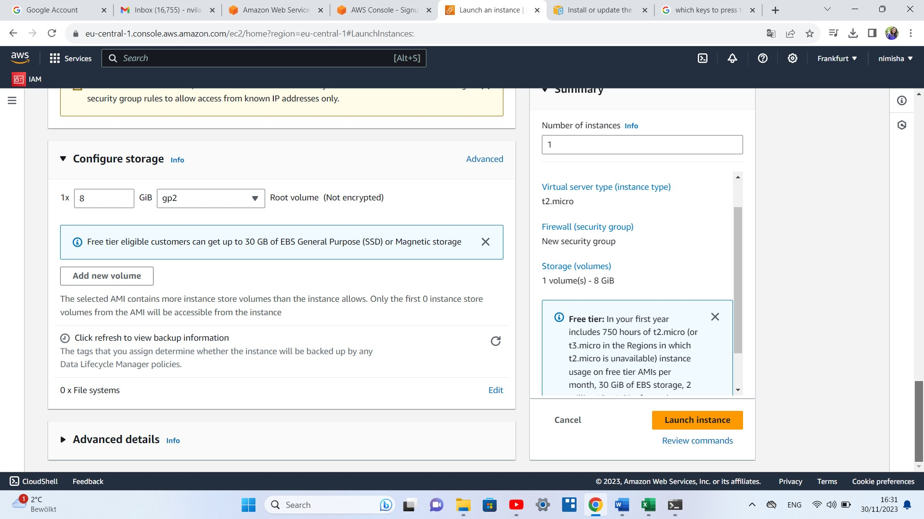

8th step our ec2 instance successfully launched

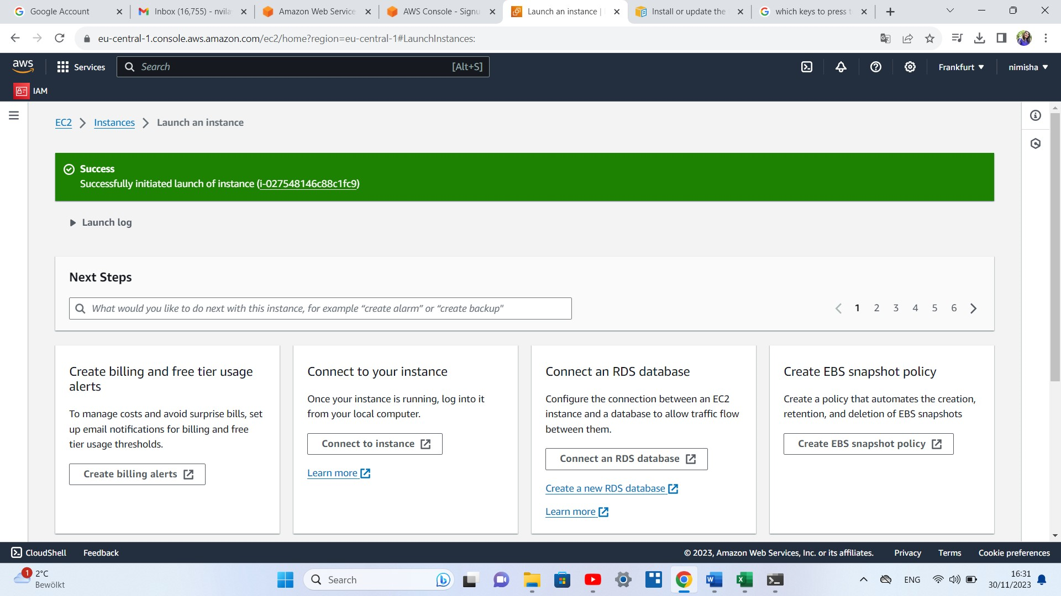

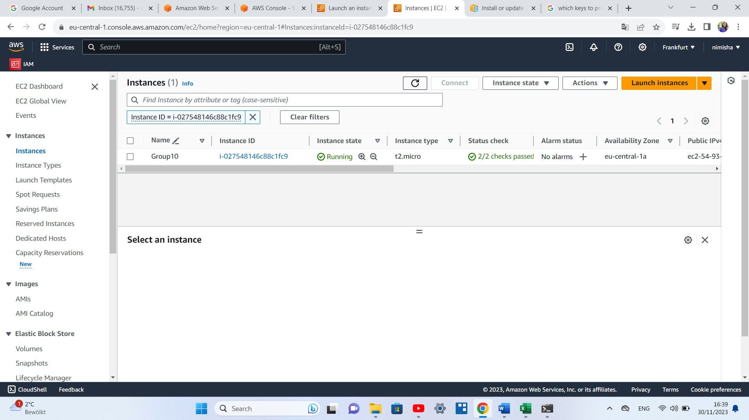

## Task 1.2

How can you connect to the EC2 Instance? Which IP address did you use to connect to it?

Ans:- In the EC2 Instances dashboard, find Our instance and look for the "Public IP" or "Public DNS (IPv4)" column. This is the address we will use to connect.

2nd way to connect through ssh.

We can do this in following way by typing this command through terminal.

Where pem file will replaced by our instance .pem file

In similar way path will be replace where we had put our .pem file

Ec2.user in our case replace by ubuntu

Instance ip :-the public ip which we have

ssh -i /path/to/your/private-key.pem ec2-user@instance-ip

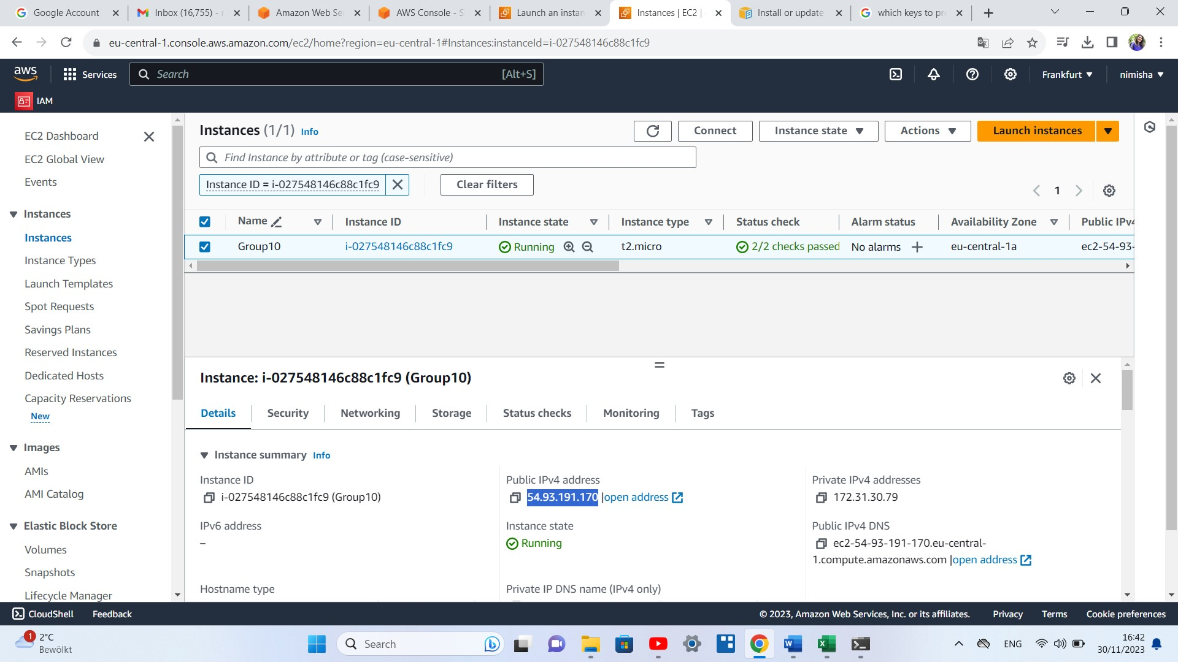

Way to connect internally by following this step on top after selecting instance we need to click on connect.

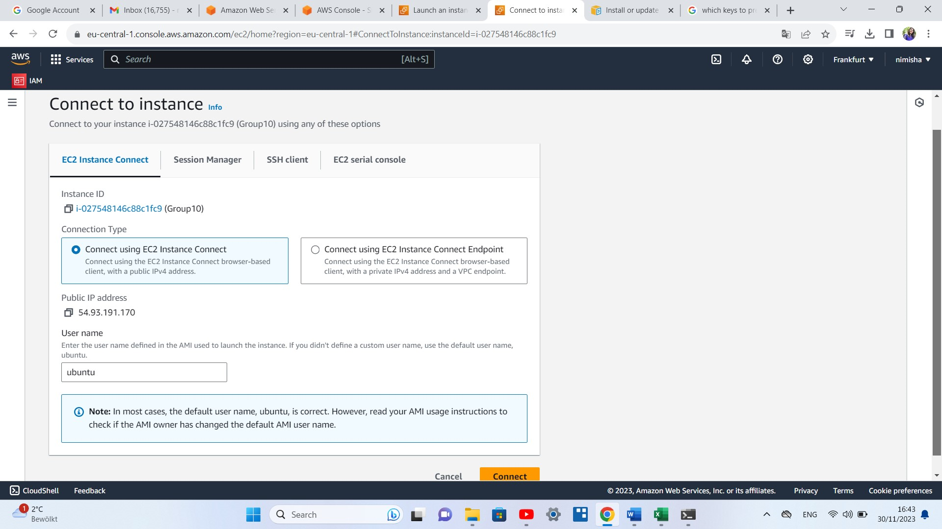

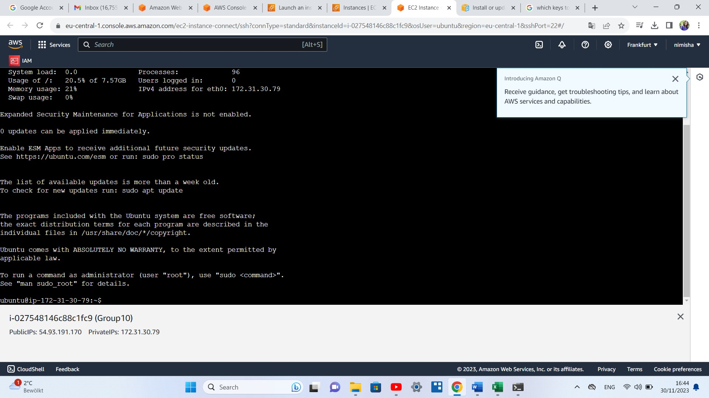

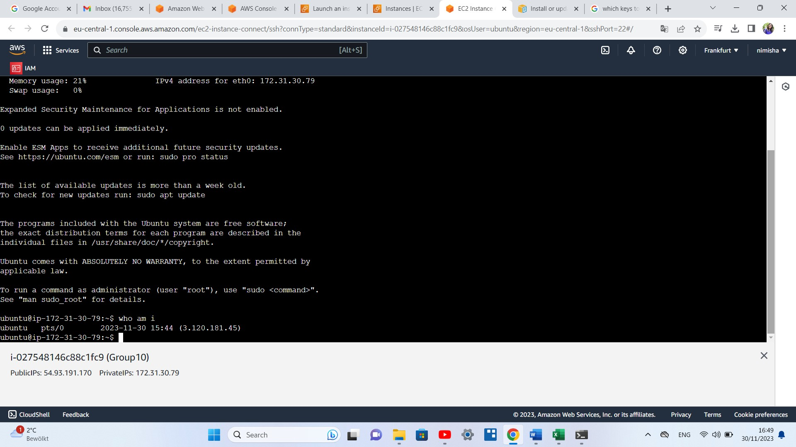

## Task 1.3

It’s time to deploy the online shop application. Use the forked store-ui repo from the GitLab Group. (Hint: You can build the application on your local system due to less resoures on EC2 Instances on VM and send the build files through SCP or PSCP tool).

What are the steps to deploy the app with Apache server on the AWS EC2 Instance?

1st step we connect from our local device to ec2 by writing this command from our command line.

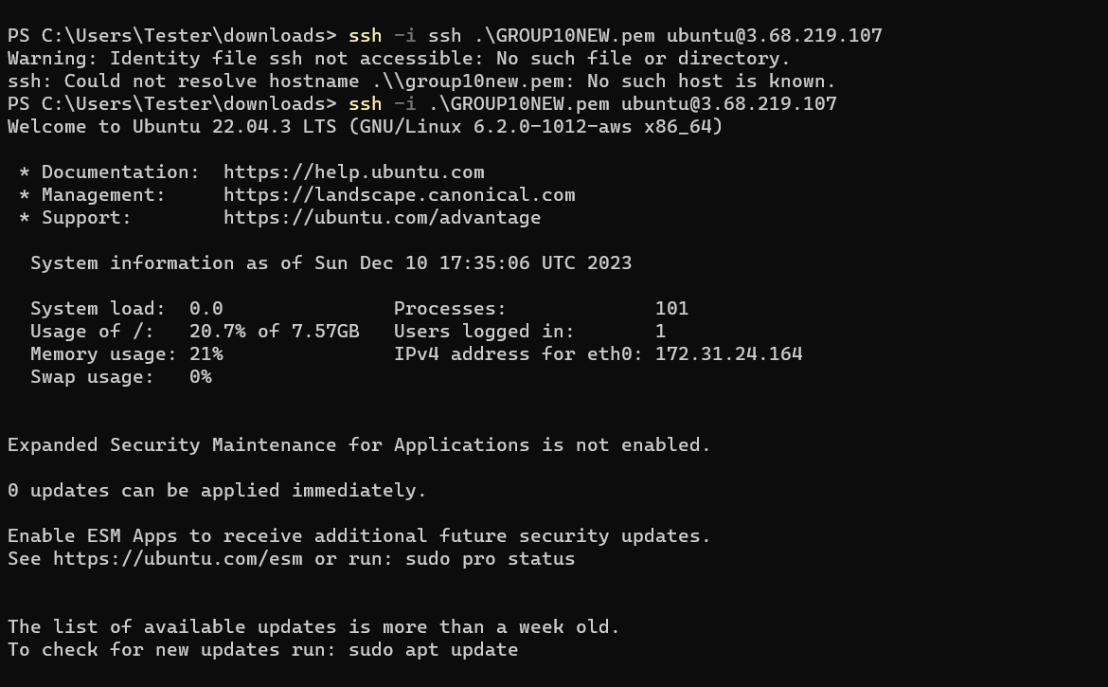

2nd step:-

Once we enter into ec2 instance we will update our system.

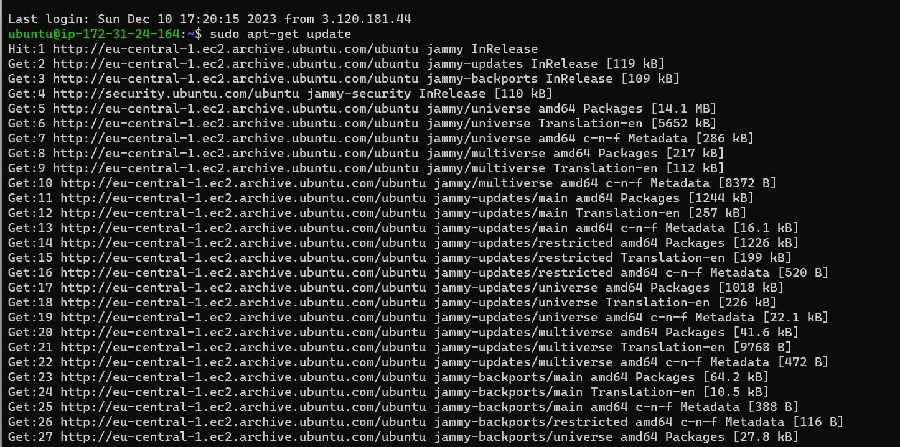

3rd step:-

We will install apache to our ec2 instance

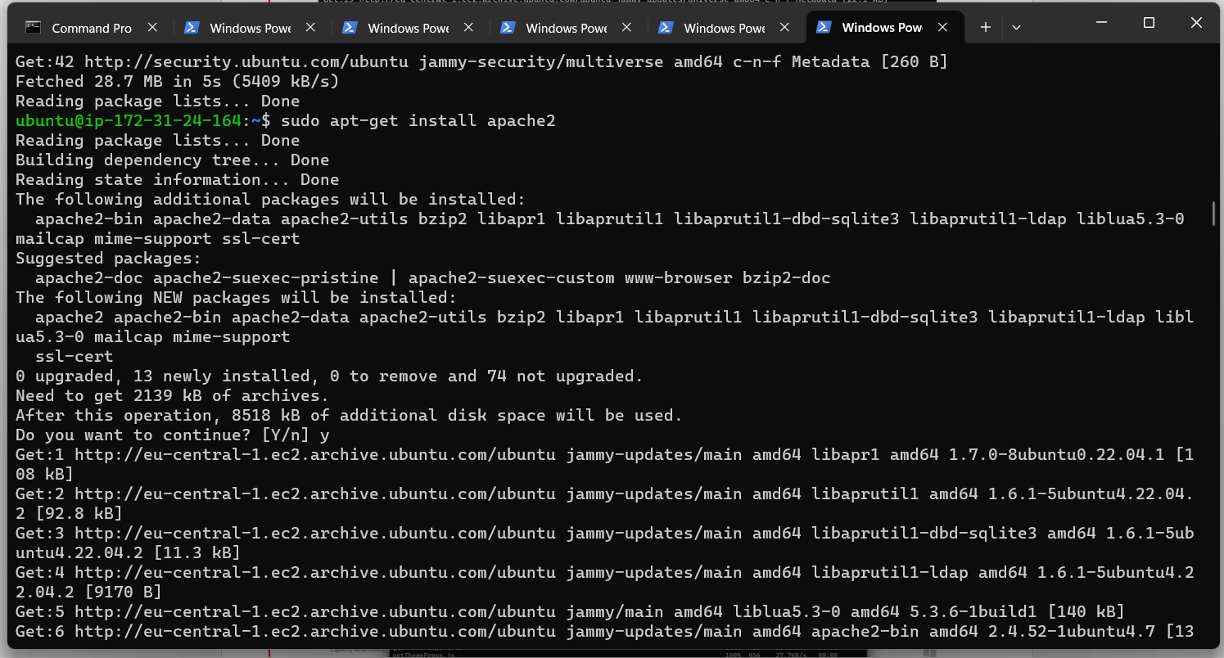

4th step:- we will start our apache2

And allow port 80

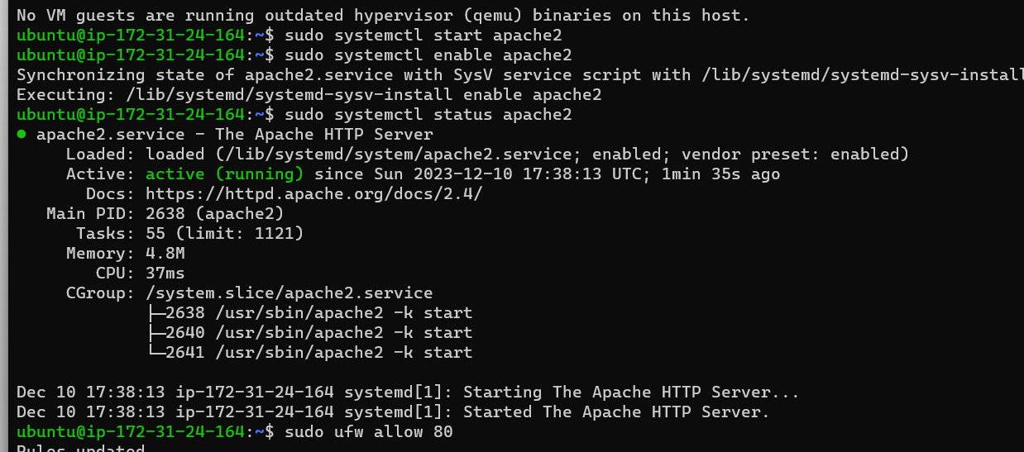

5th step :- we nee to give permission from our ec2 instance to write something on this folder so for this we will do:-



6th step :- we will copy store-ui app which is store on our local pc to ec2 instance. We will be doing this by opening another terminal and write the following command.

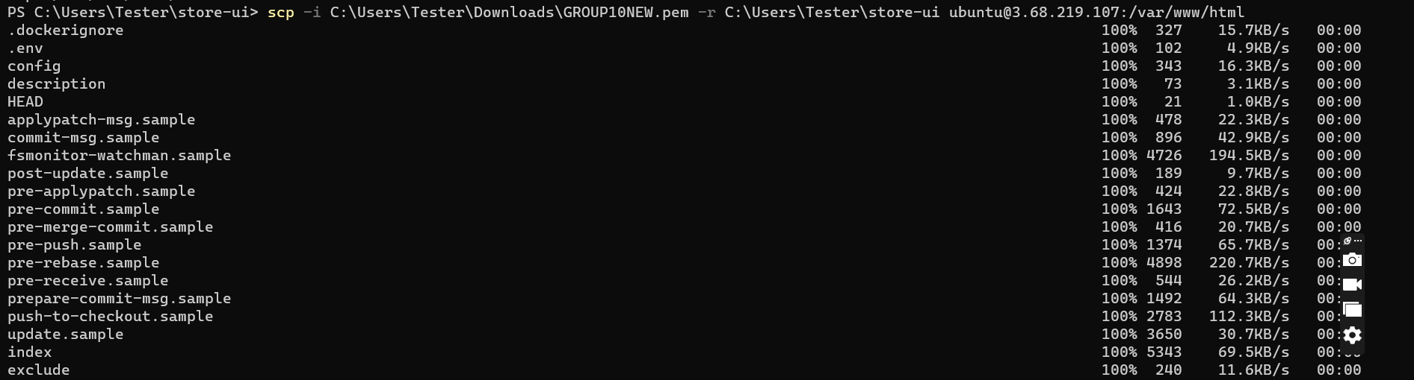

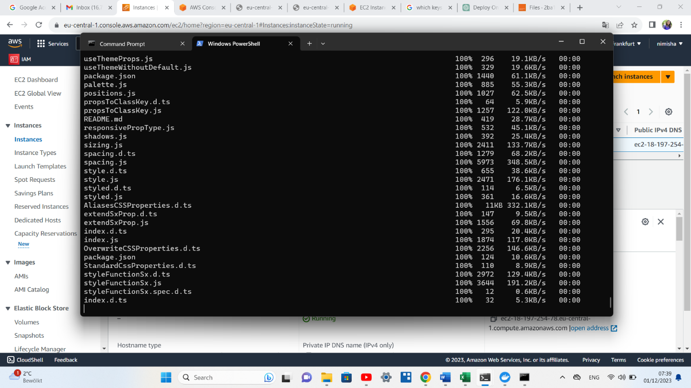

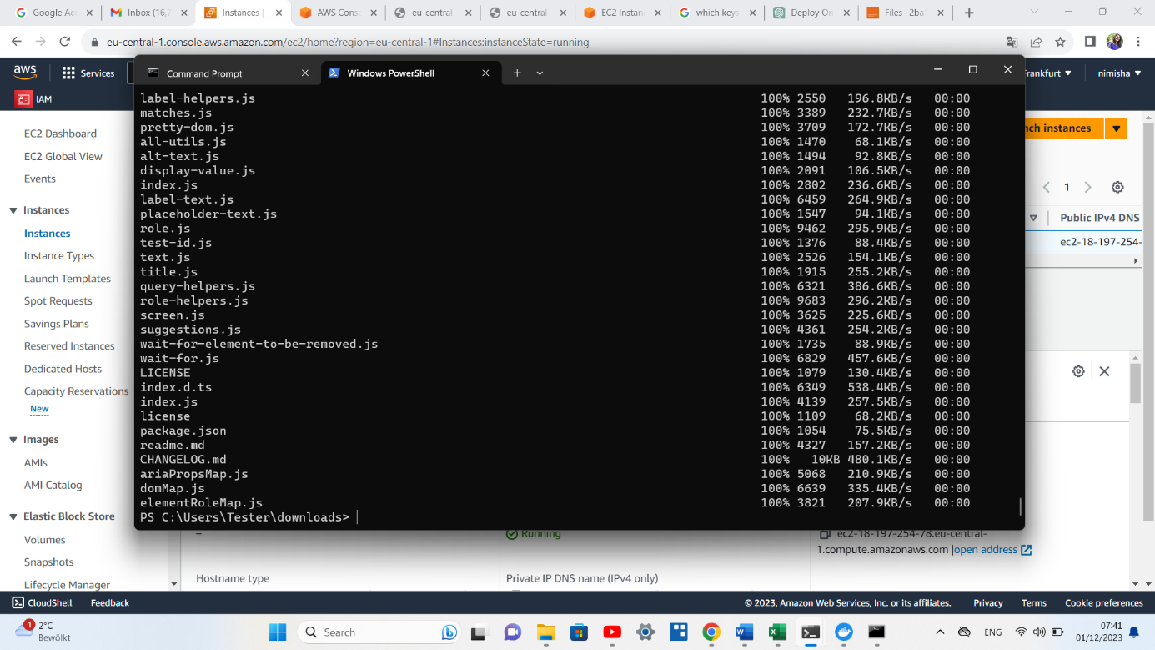



7:-step we received our store-ui on ec2 instance



## Task 1.4

Now the application is running on the apache server but how can you access it? Write all steps and add the screenshot from the browser with the URL of the store-ui running on the AWS EC2.

(Hint: Modify the inbound and outbound rules in the security group associated with your EC2 instance. Allow traffic on the necessary ports.)

1st step :- as I already have apache install and it is up and running only thing was required is inbound rule enable security port

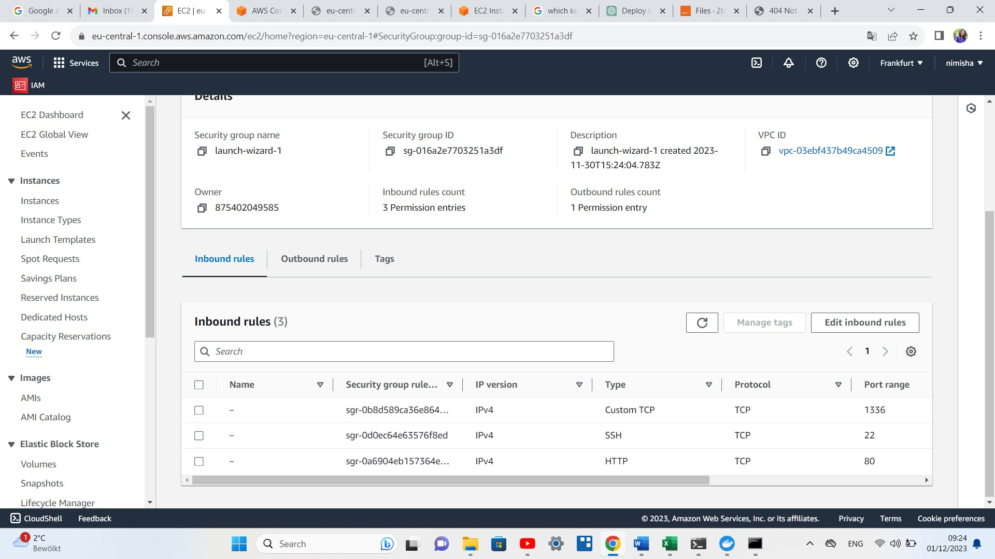

Task 1.5

Is the browser able to access and display the shop products? If not, what is the issue and how can you solve this issue?

No it wasn’t showing because the .env file wasn’t updated. For this we have edit the .env file and put the ip <http://172.22.145.110/> in the place of local host and then have to do task 1.3 agein .While re mob=ving we have to write this command : while re moving put this command sudo rsync -av /var/www/html/store-ui/build/\* /var/www/html/. The screenshot is attach below:

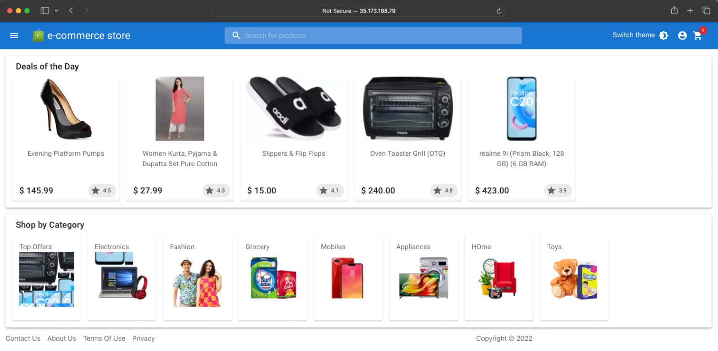

# Part 3 – Reflective Tasks

Reflective tasks, are activities or questions that encourage you to think deeply, critically, and introspectively about a specific experience, topic, or concept.

## Task 3.1

Efficiency Assessment:

· What about testing the application on AWS with respect to compute performance, security and availability?

Testing an application on AWS (Amazon Web Services) can provide valuable insights into compute performance, security, and availability. Here's an overview of how you might approach each aspect:

**1. Compute Performance:**

a. Instance Types: AWS offers various instance types optimized for different workloads. Choose instances that match your application's requirements. For example, use compute-optimized instances for CPU-intensive tasks or GPU instances for parallel processing.

b. Autoscaling: Test the ability of your application to scale horizontally with AWS Auto Scaling. Ensure that your application can efficiently handle varying loads by automatically adjusting the number of instances based on demand.

c. Load Testing: Use tools like AWS Load Balancer and Apache JMeter to simulate various levels of user activity. Monitor the performance metrics such as response time, throughput, and error rates to identify bottlenecks and optimize resource utilization.

**2. Security:**

a. IAM (Identity and Access Management): Evaluate the security of your application by defining and testing IAM roles and permissions. Ensure that only authorized users and services have access to resources.

b. VPC (Virtual Private Cloud): Assess the network security by configuring VPCs with proper subnets, security groups, and network ACLs. Test the application's resilience against network attacks.

c. Encryption: Validate the encryption of data in transit and at rest. Use services like AWS Key Management Service (KMS) for key management and AWS Certificate Manager for SSL/TLS certificates.

d. Compliance: Ensure your application complies with industry-specific standards and regulations. AWS provides compliance reports and certifications for various standards.

**3. Availability:**

a. High Availability Architecture: Design your application for high availability using AWS services like Elastic Load Balancing, Auto Scaling, and multi-AZ deployments. Test the application's ability to recover from failures.

b. Disaster Recovery: Implement and test disaster recovery strategies using AWS services like AWS Backup and AWS Elastic Disaster Recovery. Ensure data backups are regularly performed and can be restored efficiently.

c. Monitoring and Logging: Set up AWS CloudWatch for monitoring and AWS CloudTrail for auditing. Create alarms to detect and respond to issues in real-time. Analyze logs to troubleshoot and improve application performance.

General Recommendations:

a. Cost Management: Monitor and optimize costs using AWS Cost Explorer. Implement cost-saving measures such as reserved instances or spot instances based on your application's usage patterns.

b. Geographic Testing: Evaluate the performance and availability of your application in different AWS regions to ensure a consistent user experience globally.

c. Integration Testing: Test third-party integrations and services to ensure seamless communication and data flow between components.

By conducting thorough testing across these areas, you can ensure that your application is not only performant and secure but also highly available on the AWS cloud infrastructure. Regularly review and update your testing strategy as your application evolves and AWS introduces new services and features.

## Task 3.2

Scalability Assessment:

· What do you think is it possible to scale the AWS EC2 instance vertically and horizontally and also is it possible to scale the AWS Container Service?

Yes, AWS provides options for both vertical and horizontal scaling for EC2 instances and AWS Container Service (ECS).

**1. Vertical Scaling for EC2 Instances:**

Vertical scaling involves increasing the resources of a single instance to handle increased load. In AWS, you can vertically scale EC2 instances by:

a. Changing Instance Types: You can change the instance type to one with more CPU, memory, or other resources to meet the application's requirements.

b. Resizing EBS Volumes: If storage capacity is a bottleneck, you can resize Elastic Block Store (EBS) volumes attached to your EC2 instances.

c. Enhanced Networking: For network-intensive workloads, you can enable enhanced networking features.

Vertical scaling is suitable when your application requires more power from a single instance.

**2. Horizontal Scaling for EC2 Instances:**

Horizontal scaling involves adding more instances to distribute the load. AWS provides several tools to facilitate horizontal scaling:

a. Auto Scaling Groups: Create Auto Scaling Groups to automatically adjust the number of EC2 instances based on demand. It helps maintain a desired number of instances across multiple Availability Zones.

b. Load Balancers: Distribute incoming application traffic across multiple instances to ensure that no single instance is overwhelmed.

Horizontal scaling is typically more cost-effective and resilient than vertical scaling, as it allows your application to scale out and handle increased demand.

**3. Scaling AWS Container Service (ECS):**

AWS ECS supports both vertical and horizontal scaling of containerized applications.

You can vertically scale individual containers by adjusting the CPU and memory limits in your task definitions.

b. Horizontal Scaling: Use ECS features like Service Auto Scaling to automatically adjust the number of tasks (containers) in a service based on criteria you define. This can be triggered by metrics such as CPU or memory utilization.

c. Cluster Auto Scaling: Automatically add or remove EC2 instances from your ECS cluster based on demand. This is part of ECS Cluster Auto Scaling, which integrates with EC2 Auto Scaling groups.

By leveraging these scaling options, you can ensure that your EC2 instances and containerized applications on ECS can dynamically adapt to changing workloads, providing better performance, availability, and cost-efficiency.

Task 3.3

Efficiency Comparison:

· Compare the deployment of applications with docker containers and manual building of the application on AWS EC2 instance. Which approach is easier and more efficient?

The choice between deploying applications with Docker containers and manually building applications on AWS EC2 instances depends on various factors, including your specific use case, development workflow, and infrastructure requirements. Here's a comparison of both approaches in terms of ease and efficiency:

**Docker Containers:**

**Advantages:**

Portability: Docker containers encapsulate the application and its dependencies, making it highly portable across different environments. This eliminates issues related to "it works on my machine" scenarios.

Isolation: Containers provide a level of isolation between applications and the host system, reducing potential conflicts and ensuring a consistent runtime environment.

Dependency Management: Docker allows you to define and manage dependencies using a Dockerfile, making it easier to reproduce the exact environment needed for your application.

Scalability: Docker makes it easy to scale horizontally by deploying multiple instances of containers, either manually or through orchestration tools like Docker Compose or Kubernetes.

Ecosystem: Docker has a vast ecosystem, including Docker Hub for image sharing, which can save time by using pre-built images.

**Challenges:**

Learning Curve: There might be a learning curve involved in understanding Docker and container orchestration tools.

Resource Overhead: Running multiple containers may have some resource overhead compared to running applications directly on the host.

**Manual Building on EC2 Instances:**

**Advantages:**

Simplicity: Deploying applications directly on EC2 instances can be simpler, especially for smaller applications or development/testing purposes.

Direct Control: You have direct control over the underlying environment, allowing for specific configurations and optimizations tailored to your application.

No Container Overhead: Running applications directly on EC2 instances might result in lower resource overhead compared to running containers.

**Challenges:**

Dependency Management: Manually managing dependencies and ensuring consistency across environments can be challenging.

Scaling: Horizontal scaling might require more manual effort compared to container orchestration tools.

Environment Consistency: Ensuring consistent environments across different stages of development and between team members can be challenging.

**Conclusion:**

Ease of Use: For simplicity and ease of use, especially in smaller projects or when direct control over the environment is crucial, deploying directly on EC2 instances might be easier.

Efficiency and Portability: For larger and more complex applications, or when scalability and portability are critical, Docker containers provide a more efficient and scalable solution.

In many modern applications, containerization with Docker has become a popular choice due to its benefits in terms of consistency, scalability, and portability. However, the specific needs of your project and your team's expertise should guide your decision. It's also worth noting that these approaches are not mutually exclusive, and some applications might benefit from a hybrid approach, using containers for certain components and deploying others directly on EC2 instances.